**CIS-350  
Infrastructure Technologies**

**Lab 1 Report**

**Student Name**: **ETHAN GRIMES**

**You must use this template to hand in Lab1 Report.**

1. Insert the *Lab1_Tree* file from p. 25 of the Lab1 instructions into the space provided or use the *Alt-PrtScr* keys to capture the full screen output (full window) from command *TYPE Lab1_Tree* on p. 25 and paste that window here.

1. Below you have the following directory structure. At the top there is the root directory denoted by a backslash "\". *CLASSES*, *DOS*, *WINDOWS*, *BOOK*, *FINANCE*, etc. are the names of subdirectories residing under the root directory; *CONFIG.SYS* is the name of a file residing in the root directory, and *chkdsk.exe*, *CHAPTER1.DOC*, *Q.EXE*, etc. are the names of the files stored in the subdirectories. The system prompt displays"*C:****\****>*" which means that the current/default drive is *C* and the current/default directory is the root directory "**\**". The root directory "**\**" is just the origin for other directories/subdirectories.

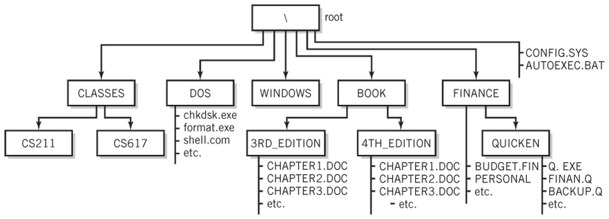

All questions (a) through (j) are based on the above directory diagram. For questions (a) through (f) assume the prompt "*C:* *>*" is displayed.

1. Write a command to copy file *CONFIG.SYS* to directory *DOS*. The copied file should have the same name as the original file, i.e., *CONFIG.SYS*.

COPY CONFIG.SYS C:\DOS

1. Write a command to copy a file *CONFIG.SYS* to directory *QUICKEN*. The copied file should have new name *CONFIG1.SYS*.

COPY CONFIG.SYS C:\QUICKEN\CONFIG1.SYS

1. Write a single command to copy all files whose names start with letter *C* from directory *4TH_EDITION* to directory *FINANCE*.

\BOOK\4TH_EDITION>COPY C?.DOC C:\FINANCE

1. Write a single command to erase from directory *4TH_EDITION* all files whose names start with letter *C*.

\BOOK\4TH_EDITION>ERASE C?.DOC

1. How many files would be erased by the command from p. (d) above?

3 Files

1. Assume that *AUTOEXEC.BAT* is a large file. What command would you use to display the contents of the file one screen at a time (to prevent the output from scrolling off the screen)?

DIR\AUTOEXEC.BAT|MORE

1. Look at the diagram. Assume that prompt "*C:\FINANCE\QUICKEN>*" is displayed, meaning that the current/default drive is *C* and the current/default directory is *\FINANCE\QUICKEN*. Write two separate *SORT* commands. Each of the two commands would accept input from file *BACKUP.Q*. However, the first command would route the output to file *BACKUP1.Q*, and the second one would append the output to file *BACKUP2.Q*.

SORT<BACKUP.Q>BACKUP1.Q

SORT<BACKUP.Q>>BACKUP2.Q

1. Look at the diagram. Assume that prompt "*C:\FINANCE\QUICKEN>*" is displayed. Write the command which would change the current directory to *FINANCE*.

CD..

1. Look at the diagram. Assume that prompt "*C:\FINANCE>*" is displayed. In the space provided, sketch the directory structure with the subdirectory and file names which would command *TREE* /F generate.

1. Now assume that the "C:\ " prompt is displayed. Describe what a command

*DIR | SORT > DirList* would do.

The directory list would be opened and then sorted by using the SORT filter. The sorted files are then placed into a temporary file and finally sent to the file DirList.

1. Optional. Briefly describe any issues with the commands which did not work. Point me to the specific pages and suggest changes. Thanks.

I had no major issues with this lab.